Media Accreditation Request

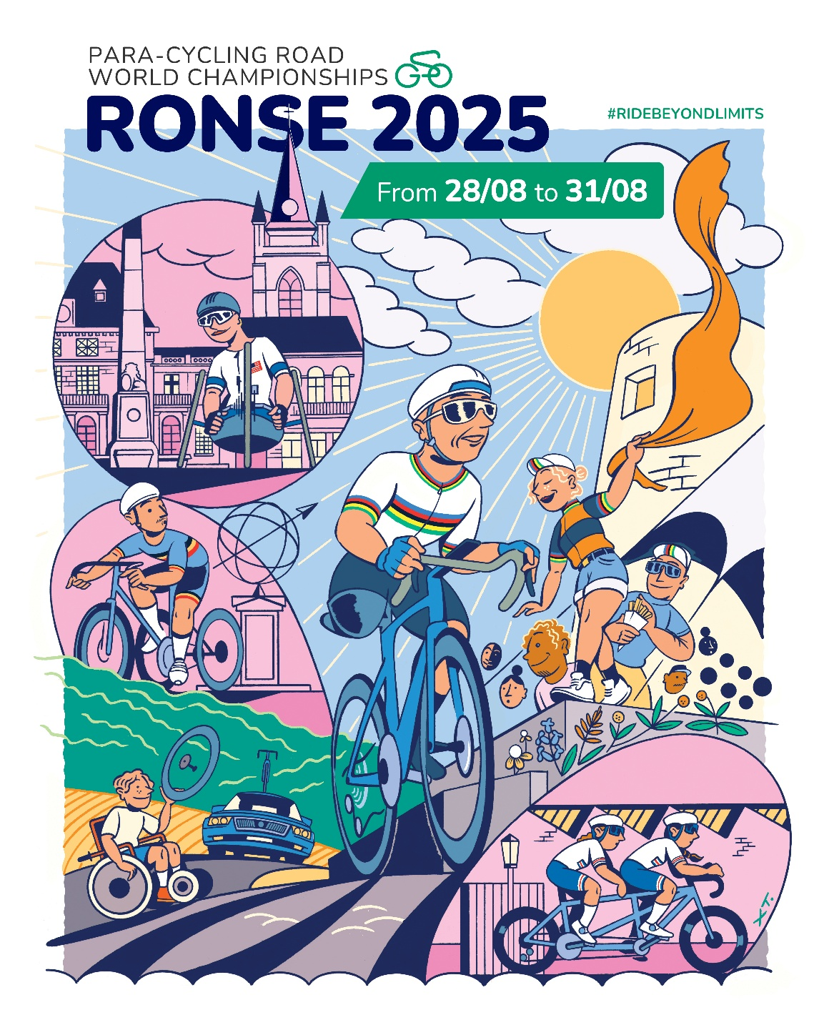

Media guide
Ronse 2025

Country: …………………………………….. Code: ……………………………….
LAST NAME, first name: ……………………………………………………………………………….
Adress: …………………………………………………………………………………………………………….
…………………………………………………………………………………………………………………………..

Press Card type and number
Date of Birth
Mobile phone
E-mail
Media
Website
Type of media

Only freelance reporters/photographers or media agencies with confirmed media clients will be assessed for accreditation.
Freelancers must provide the following details of their media client(s):
Name Media Client(s)
Phone Media Client(s)
E-mail Media Client(s)

To support this application, attach the following documents:
- A copy of your valid press card
- Signed assignment letter from media client, signed by editor in chief or equivalent. Telephone number and email address to editor in chief or equivalent must be provided.

27.08.2025 | 28.08.2025 | 29.08/2025 | 30.08.2025 | 31.08.2025
YES/NO | YES/NO | YES/NO | YES/NO | YES/NO

Date: …………………………………… Signature: ……………………………………

Please return this form to by e-mail press@ronse2025.com before the 18th of August

